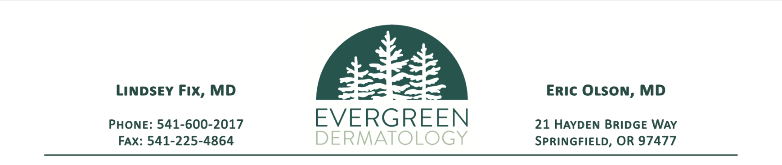

# AUTHORIZATION TO USE AND DISCLOSE PROTECTED HEALTH INFORMATION

I authorize by my signature below: Evergreen Dermatology to use and disclose a copy of the specific health information described below.

I wish to transfer:

Records and Pathology Relating to Dermatology Care

I wish to transfer such records to: (Please list physical address, provider and fax number)

The transfer is for the purpose of:

Dermatology Care

If the above health information contains any of the four types of records or information listed below, additional laws relating to the use and disclosure of that information may apply. I understand and agree that this information will be disclosed and could be redisclosed if I place my initials in the applicable space next to the type of information.

HIV/AIDS Information

Mental Health Information

Genetic testing information

Drug/alcohol diagnosis, treatment, or referral information

I acknowledge that by my signature below the information in my authorization may be subject to redisclosure and therefore no longer protected under federal law. I also understand that federal or state law may restrict the redisclosure of HIV/AIDS information, mental health information, genetic testing information, and drug/alcohol diagnosis, treatment or referral information.

Initials: _____________ Page 1 of 2

I am giving this authorization of my own volition and understand that if I refuse to transfer my health information my ability to receive health care services or reimbursement for services will not be affected. I acknowledge that if I request health care services solely for the purpose of providing health information to someone else, then my authorization is necessary to make that disclosure.

I understand that I may revoke this authorization in writing at any time. I further understand that if I revoke this authorization, the information described above may no longer be used or disclosed for the purposes described herein.

# SIGNATURE

I have read this authorization and I understand it.

_______________________________________________________________________________________________

Signature of Patient, Guardian or Healthcare Power of Attorney Date

_______________________________________________________________________________________________

Printed Name Date of Birth