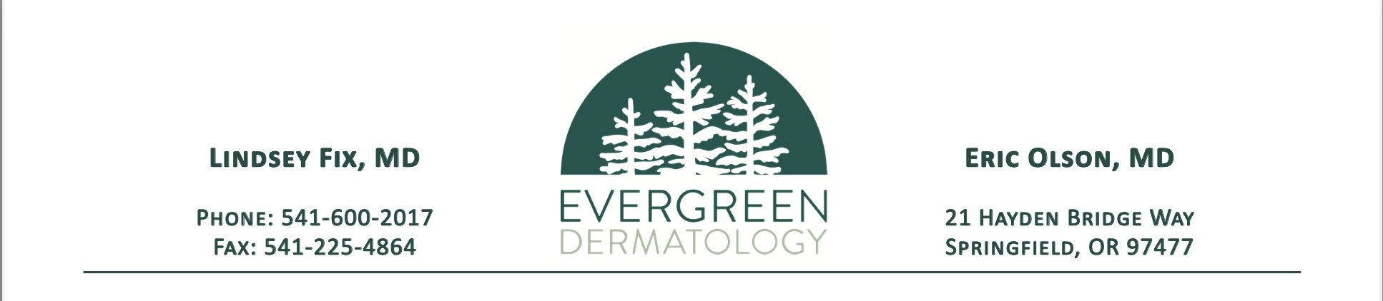

**Surgery Referral Form**

From**: _________________________ ________________ ________________**

**Referring Provider Name Clinic Name Clinic Phone Number**

**I am writing to refer the following patient for:**

[ ] Excision

[ ] Staged Excision/Slow Mohs

[ ] Mohs Surgery

[ ] Other___________________

**Surgery is requested for the following condition(s):**

[ ] Basal Cell Carcinoma (BCC)

[ ] Squamous Cell Carcinoma/in situ (SCC/SCCis)

[ ] Melanoma

[ ] Other___________________

**Patient Information:** (ok to skip if face sheet is sent and up-to-date)

[ ] Patient Name: ______________________________

[ ] Date of Birth: ­­­­­______________________________

[ ] Phone number: _____________________________

**Additional Information:** Please, check any that apply.

[ ] Lesion is recurrent

[ ] Malignancy is greater than 2cm

[ ] Patient is immunosuppressed

**Attachments:** Please attach the following:

[ ] Demographics or face sheet so our office can contact the patient

[ ] Pathology Report

[ ] Clinical photo or diagram

**Please fax this referral form to Evergreen Dermatology at 541-225-4864. Documents can also be sent via direct mail through EMA to KHansell@evergreenderm.emadirect.md**