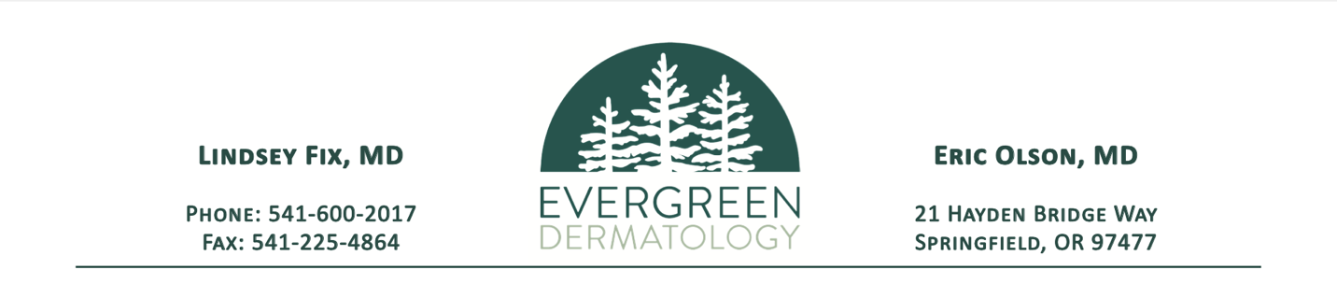

**Financial Policy**

Evergreen Dermatology is dedicated to providing the best possible care to our patients. To reduce confusion, we have adopted the following financial policies. Please contact our billing office at (541) 600-2017 if you have any questions regarding these policies.

**Insurance Coverage:** We ask that you provide us with your current insurance information at the time of scheduling each appointment and notify us of any changes. This will ensure our office can bill your insurance plan for you. We will also be scanning in a copy of your insurance card and photo ID for your chart as required by insurance plan requirements. Please note that it is your responsibility to understand the coverage and benefits your health insurance plan provides, including knowledge of any deductible, copayments, and/or coinsurance.

We are in-network with most insurance carriers and will accept the assignment of benefits. If our clinic is out of network with your plan, we will bill them as a courtesy but you may have a higher out-of-pocket cost. It is the patient’s responsibility to be sure your doctor is in-network and the services are covered.

**Self-Pay:** Self-pay patients are those patients without insurance coverage or receiving a service not covered by their plan. For self-pay patients, we require a $50.00 deposit before scheduling. We also offer a 10% discount if the remaining balance is paid in full at the time of service.

**Payments:** Your statement will be mailed or emailed to you once we have received a response from your insurance plan. All balances are due within 30 days of receipt of the statement. For your convenience, we accept cash, checks, or credit cards (Visa, Mastercard, Discover, American Express). Failure to do so may result in further collection activity which may include referral to an outside collection agency and/or inability to schedule further appointments. If you are unable to pay the balance within 30 days, please contact our billing department to discuss our payment plan options.

**Missed Appointments/Late Cancellations:** Our office policy is to require at least 24 hours' notice of cancellation of any office visit or procedure. Failure to provide adequate notice may result in a missed appointment/late cancellation fee of $50.00. This fee will not be billed to your insurance company and is the sole responsibility of the guarantor.

**I have read and understand Evergreen Dermatology’s Financial Policy and agree to be bound by its terms.**

**___________________________________ _________________**

**Signature of Patient or Responsible Party Date**

**___________________________________ _________________**

**Printed Name of Patient Date of Birth**